This project was created as a repository to post the solutions for Assignments 1-6 posted in the Programming Java SE [2023F_CSD_3464_G1] class.

Authors:

Alexander Gutierrez

Can Zorbey

David Barrios

Paul Jordan

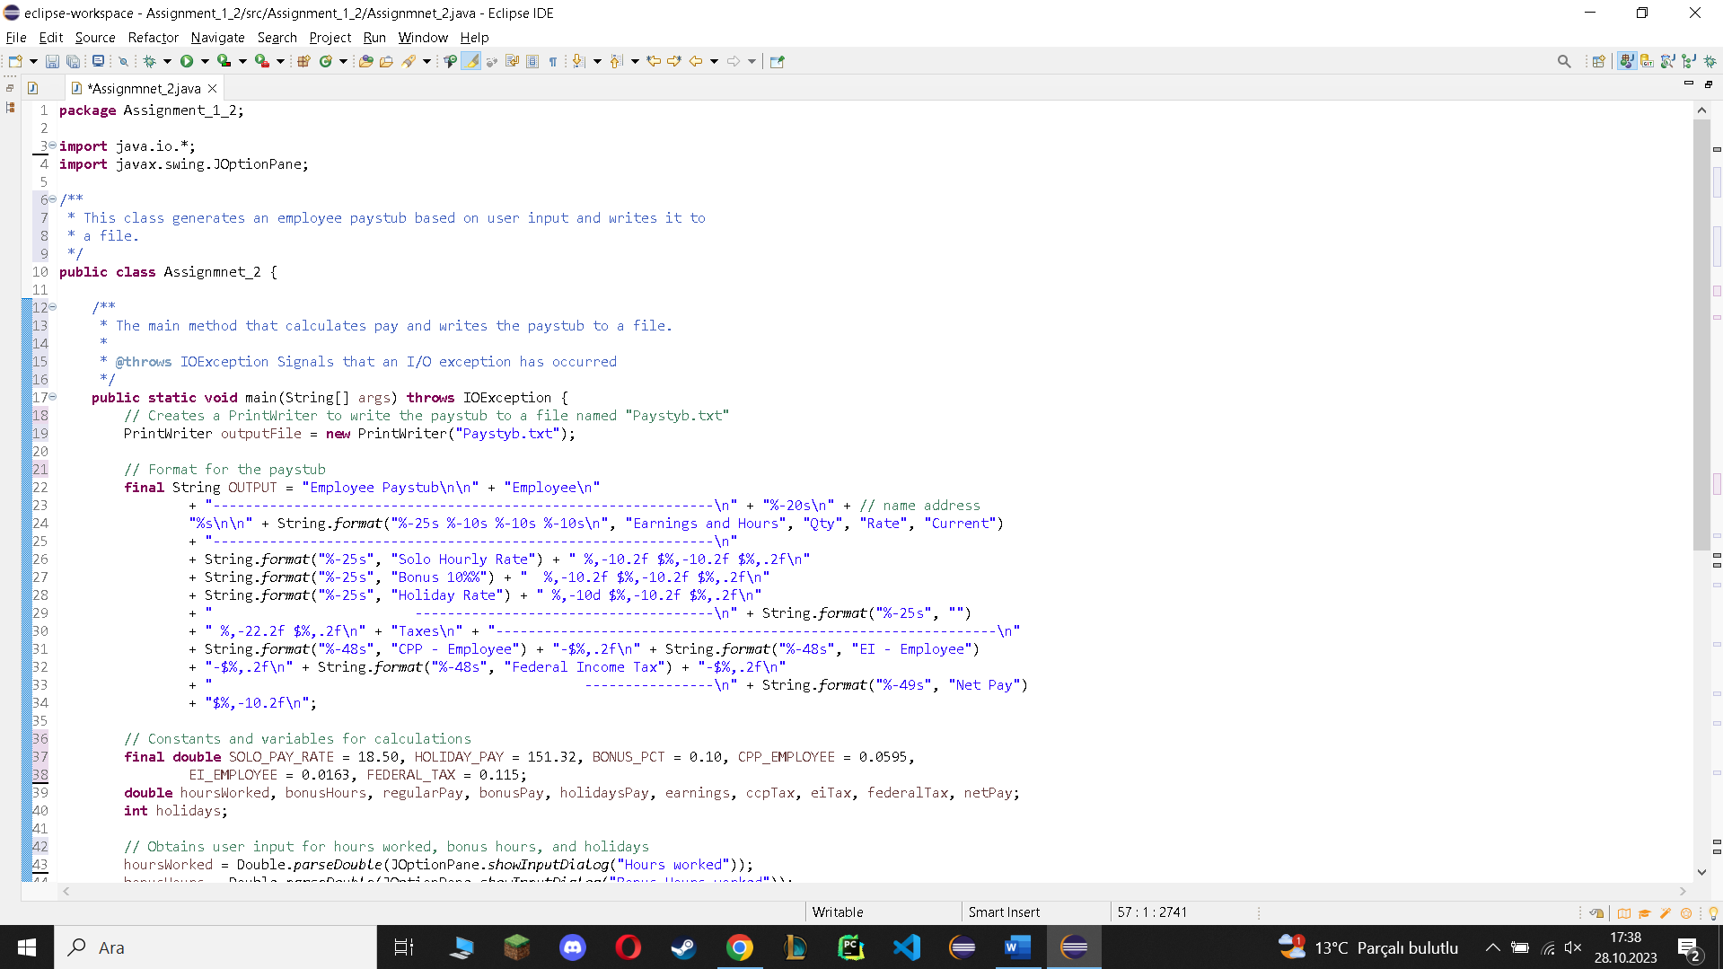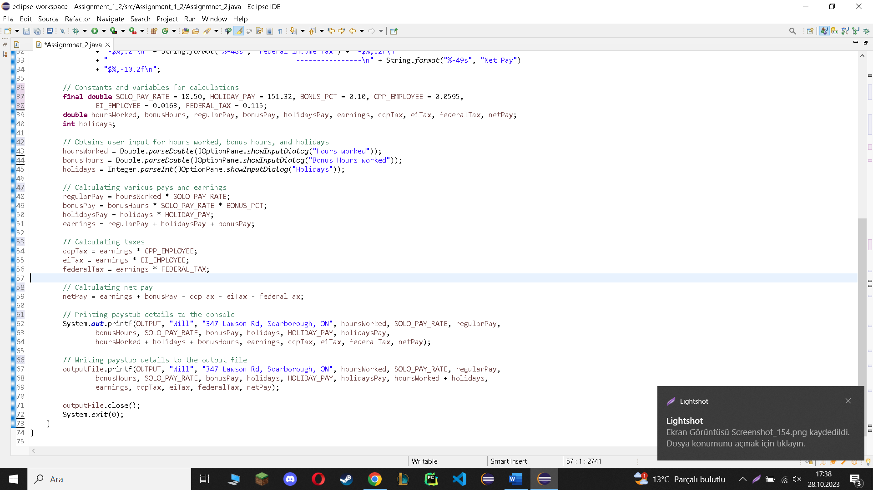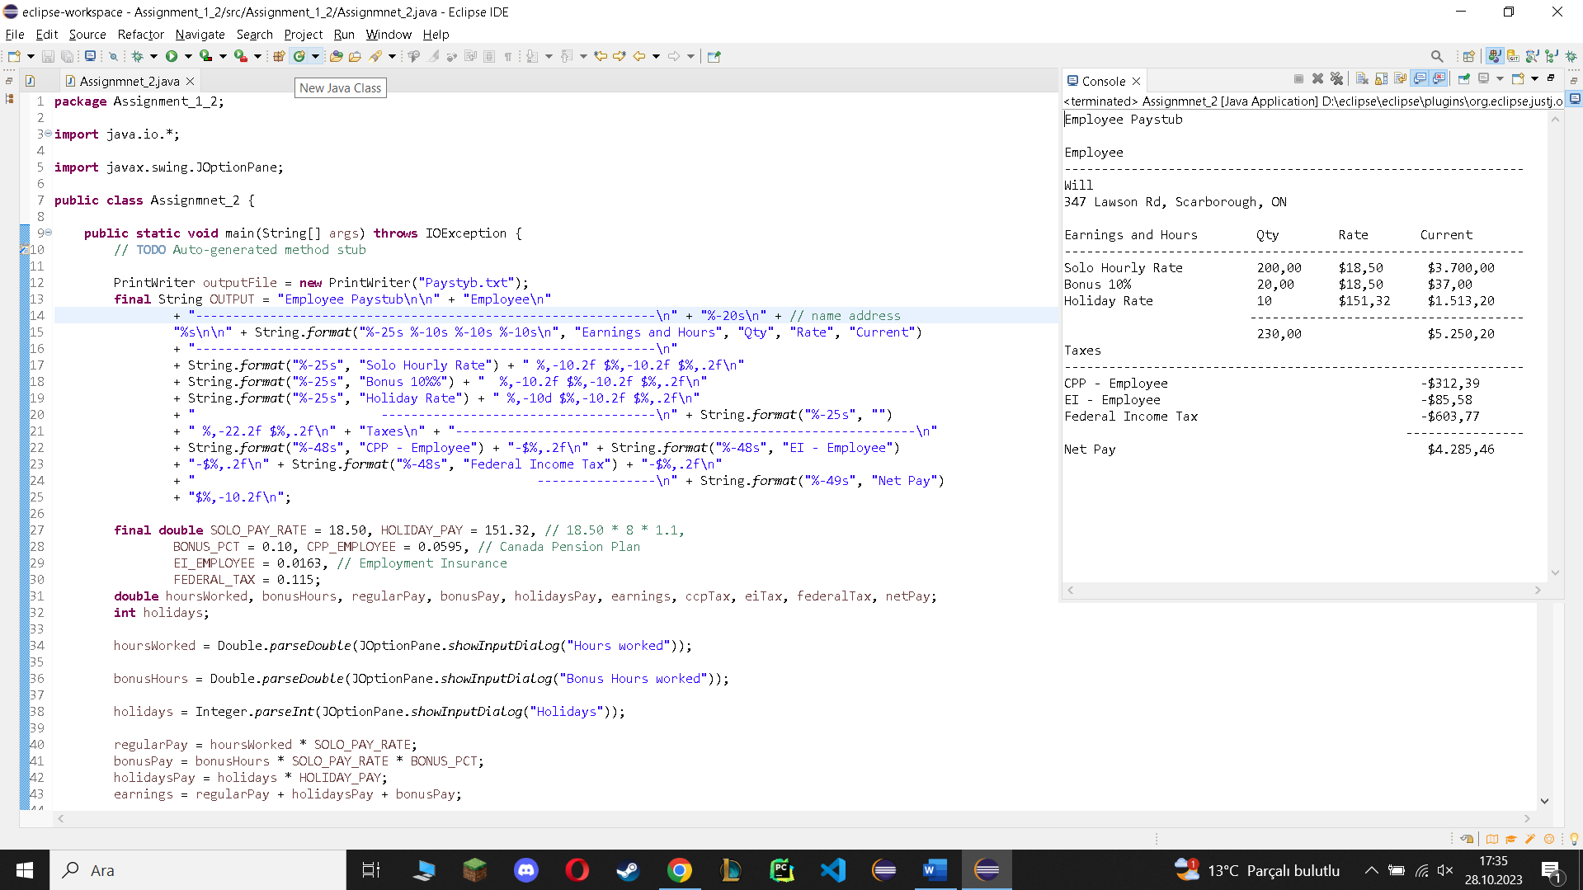

**package** Assignment_1_2;

**import** java.io.*;

**import** javax.swing.JOptionPane;

/**

* This class generates an employee paystub based on user input and writes it to

* a file.

*/

**public** **class** Assignmnet_2 {

/**

* The main method that calculates pay and writes the paystub to a file.

*

* **@throws** IOException Signals that an I/O exception has occurred

*/

**public** **static** **void** main(String[] args) **throws** IOException {

// Creates a PrintWriter to write the paystub to a file named "Paystyb.txt"

PrintWriter outputFile = **new** PrintWriter("Paystyb.txt");

// Format for the paystub

**final** String OUTPUT = "Employee Paystub\n\n" + "Employee\n"

+ "--------------------------------------------------------------\n" + "%-20s\n" + // name address

"%s\n\n" + String.*format*("%-25s %-10s %-10s %-10s\n", "Earnings and Hours", "Qty", "Rate", "Current")

+ "--------------------------------------------------------------\n"

+ String.*format*("%-25s", "Solo Hourly Rate") + " %,-10.2f $%,-10.2f $%,.2f\n"

+ String.*format*("%-25s", "Bonus 10%%") + " %,-10.2f $%,-10.2f $%,.2f\n"

+ String.*format*("%-25s", "Holiday Rate") + " %,-10d $%,-10.2f $%,.2f\n"

+ " -------------------------------------\n" + String.*format*("%-25s", "")

+ " %,-22.2f $%,.2f\n" + "Taxes\n" + "--------------------------------------------------------------\n"

+ String.*format*("%-48s", "CPP - Employee") + "-$%,.2f\n" + String.*format*("%-48s", "EI - Employee")

+ "-$%,.2f\n" + String.*format*("%-48s", "Federal Income Tax") + "-$%,.2f\n"

+ " ----------------\n" + String.*format*("%-49s", "Net Pay")

+ "$%,-10.2f\n";

// Constants and variables for calculations

**final** **double** SOLO_PAY_RATE = 18.50, HOLIDAY_PAY = 151.32, BONUS_PCT = 0.10, CPP_EMPLOYEE = 0.0595,

EI_EMPLOYEE = 0.0163, FEDERAL_TAX = 0.115;

**double** hoursWorked, bonusHours, regularPay, bonusPay, holidaysPay, earnings, ccpTax, eiTax, federalTax, netPay;

**int** holidays;

// Obtains user input for hours worked, bonus hours, and holidays

hoursWorked = Double.*parseDouble*(JOptionPane.*showInputDialog*("Hours worked"));

bonusHours = Double.*parseDouble*(JOptionPane.*showInputDialog*("Bonus Hours worked"));

holidays = Integer.*parseInt*(JOptionPane.*showInputDialog*("Holidays"));

// Calculating various pays and earnings

regularPay = hoursWorked * SOLO_PAY_RATE;

bonusPay = bonusHours * SOLO_PAY_RATE * BONUS_PCT;

holidaysPay = holidays * HOLIDAY_PAY;

earnings = regularPay + holidaysPay + bonusPay;

// Calculating taxes

ccpTax = earnings * CPP_EMPLOYEE;

eiTax = earnings * EI_EMPLOYEE;

federalTax = earnings * FEDERAL_TAX;

// Calculating net pay

netPay = earnings + bonusPay - ccpTax - eiTax - federalTax;

// Printing paystub details to the console

System.***out***.printf(OUTPUT, "Will", "347 Lawson Rd, Scarborough, ON", hoursWorked, SOLO_PAY_RATE, regularPay,

bonusHours, SOLO_PAY_RATE, bonusPay, holidays, HOLIDAY_PAY, holidaysPay,

hoursWorked + holidays + bonusHours, earnings, ccpTax, eiTax, federalTax, netPay);

// Writing paystub details to the output file

outputFile.printf(OUTPUT, "Will", "347 Lawson Rd, Scarborough, ON", hoursWorked, SOLO_PAY_RATE, regularPay,

bonusHours, SOLO_PAY_RATE, bonusPay, holidays, HOLIDAY_PAY, holidaysPay, hoursWorked + holidays,

earnings, ccpTax, eiTax, federalTax, netPay);

outputFile.close();

System.*exit*(0);

}

}